ASSIGNMENT-8.5
Name: G.Vignesh
Hall No:2303A52359
Batch:36
Task Description #1 (Username Validator – Apply AI in
Authentication Context)
- Task: Use AI to generate at least 3 assert test cases for a function is_valid_username(username) and then implement the function using Test-Driven Development principles.
- Requirements:
- Username length must be between 5 and 15 characters. o Must contain only alphabets and digits. o Must not start with a digit.
- No spaces allowed. Example Assert Test Cases:
assert is_valid_username("User123") == True assert is_valid_username("12User") == False assert is_valid_username("Us er") == False Expected Output #1:
- Username validation logic successfully passing all AI- generated test cases.
Output:
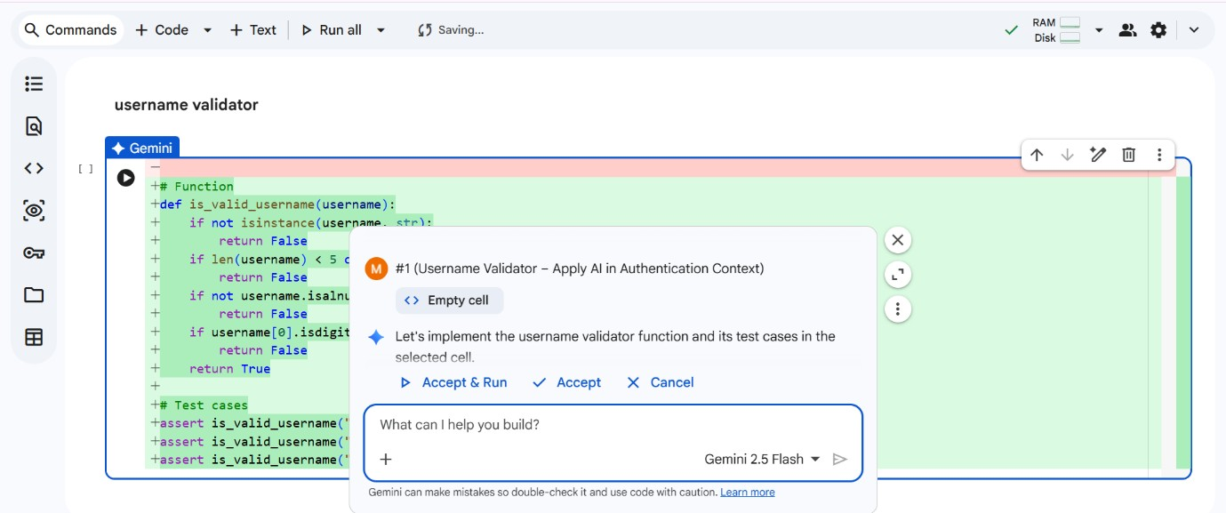
Task Description #2 (Even–Odd & Type Classification – Apply
AI for Robust Input Handling)
- Task: Use AI to generate at least 3 assert test cases for a function classify_value(x) and implement it using conditional logic and loops.
- Requirements:
- If input is an integer, classify as "Even" or "Odd".
- If input is 0, return "Zero".
- If input is non-numeric, return "Invalid Input".
Example Assert Test Cases:
assert classify_value(8) == "Even" assert classify_value(7) == "Odd" assert classify_value("abc") == "Invalid Input" Expected Output #2:
- Function correctly classifying values and passing all test cases.
Output:
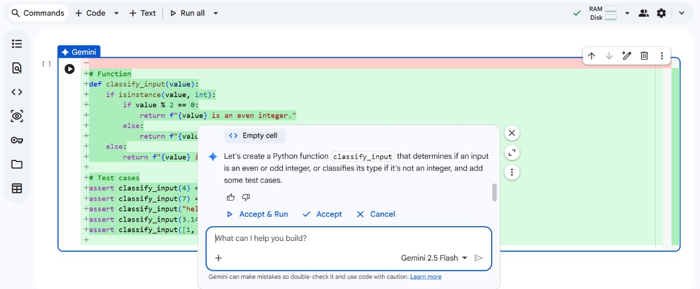
Task Description #3 (Palindrome Checker – Apply AI for
String Normalization)
- Task: Use AI to generate at least 3 assert test cases for a function is_palindrome(text) and implement the function.
- Requirements:
- Ignore case, spaces, and punctuation.
- Handle edge cases such as empty strings and single characters.
Example Assert Test Cases:
assert is_palindrome("Madam") == True
assert is_palindrome("A man a plan a canal Panama") == True
assert is_palindrome("Python") == False Expected Output #3:
- Function correctly identifying palindromes and passing all AI-generated tests.
Output:
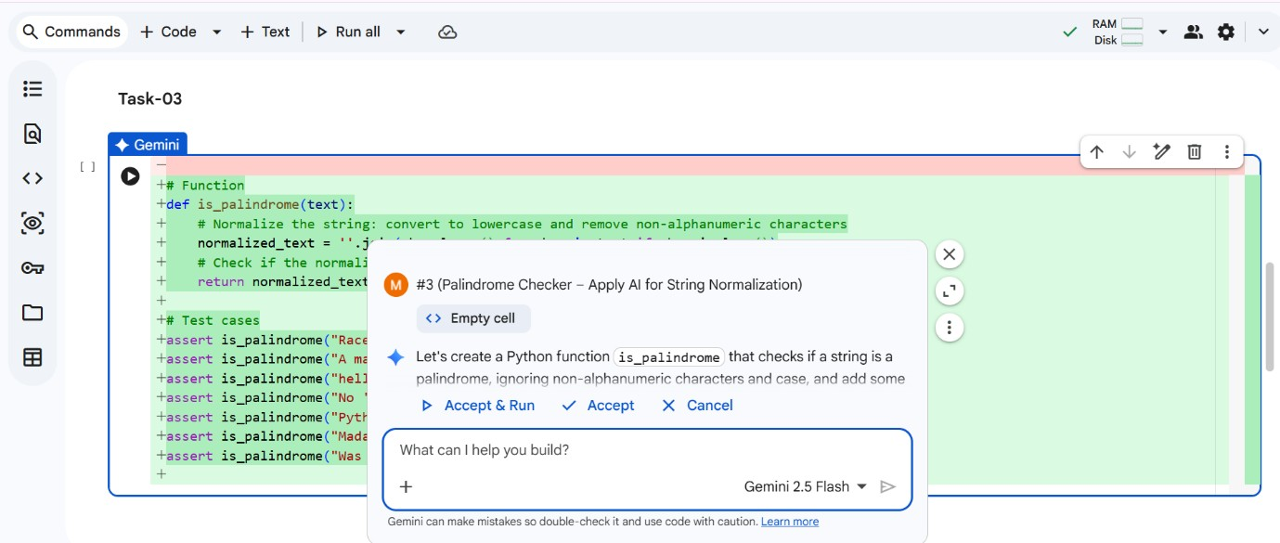
Task Description #4 (BankAccount Class – Apply AI for
Object-Oriented Test-Driven Development)
- Task: Ask AI to generate at least 3 assert-based test cases for a BankAccount class and then implement the class.
- Methods:
o deposit(amount) o withdraw(amount) o get_balance()
Example Assert Test Cases: acc = BankAccount(1000) acc.deposit(500)
assert acc.get_balance() == 1500 acc.withdraw(300)
assert acc.get_balance() == 1200 Expected Output #4:
- Fully functional class that passes all AI-generated assertions.
Output:
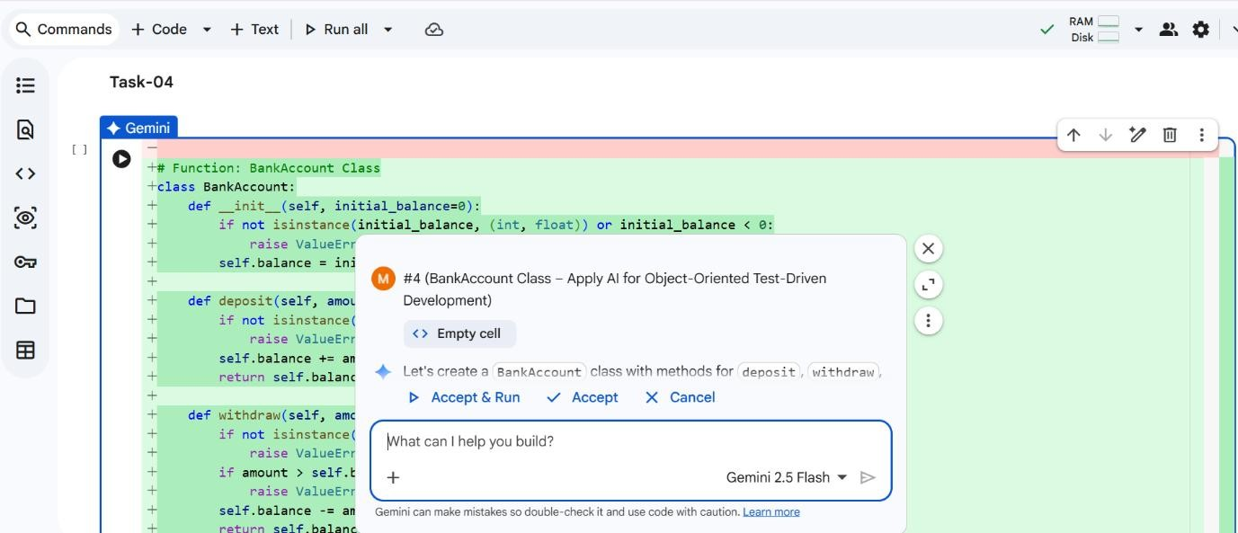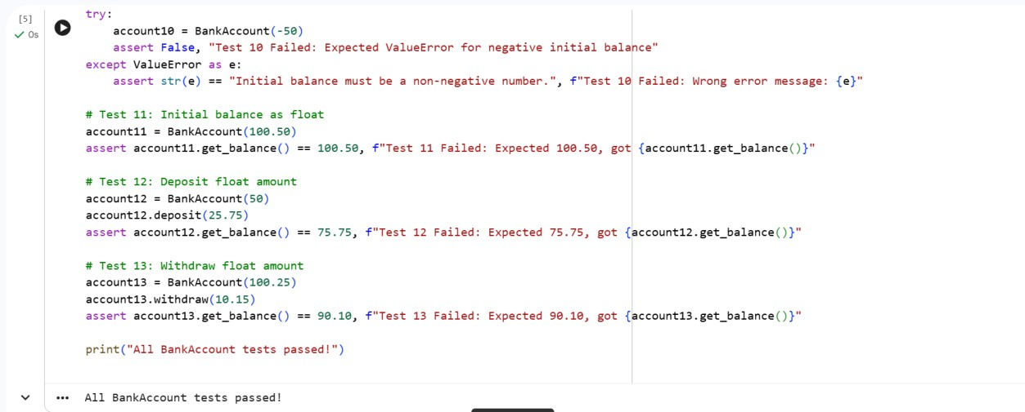
Task Description #5 (Email ID Validation – Apply AI for Data
Validation)
- Task: Use AI to generate at least 3 assert test cases for a function validate_email(email) and implement the function.
- Requirements:
o Must contain @ and . o Must not start or end with special characters. o Should handle invalid formats gracefully.
Example Assert Test Cases:
assert validate_email("user@example.com") == True assert validate_email("userexample.com") == False assert validate_email("@gmail.com") == False Expected Output #5:
• Email validation function passing all AI-generated test cases and handling edge cases correctly.
Output:
